Welcome!

Welcome to the Algoma Community Band (ACB). If you are new to the organization, we are happy to have you. If you are a seasoned player, we welcome you back.

Mission Statement
The Algoma Community Band exists to provide instrumental music for Algoma and its surrounding communities.

History
The Algoma Community Band was organized in March of 1978. Kerry Nichols was instrumental in organizing the group. The original band consisted of approximately sixty members. Membership was open to anyone interested in playing a musical instrument.

The band members have enjoyed traveling throughout Europe. They have played concerts in the following countries: Belgium, France, Germany, Switzerland, Austria, Hungary, Poland, Czech Republic, and most recently, Ireland. Closer to home concerts have been played in Washington, D.C; Columbus, OH; Chicago, IL; and various cities in Wisconsin.

Each August the band plays in the Algoma Shanty Days parade and concert. In the past, the band has been an extremely popular marching group in various parades in Wisconsin. They are very visible in the community and county playing concerts at the Kewaunee County Fair, Breakfast on the Farm, Veterans Day Concert, After Taxes Concert, Band-O-Rama, and at other local functions.

The Algoma Community Band and The Lakeshore Singers directed by Dave Robertson, have performed several concerts for the community. The band also has played several joint concerts with other community bands in the Green Bay, Door County, and Fond du Lac areas.

Without the dedication and leadership of our directors, the band would not be in existence today. We owe a great deal to the following directors: Kerry Nichols, Dale Wahlers, Mary Jo Feld, Jeff Rosendahl, Bill Dennee, Dave Kopetsky, Phil Stangel, John Nielsen, Laura Schram, and Tom Mueller.
Membership
Membership is open to persons with the skill to read music, play a musical instrument, and participate in the ACB. Participation in 75% of the concerts and performances, per year, is considered the minimum for active membership. Students capable of playing high school Class B level music are welcome with a recommendation from their band instructor, and with their parent’s permission. No audition is required. No fees are required.

Attendance Requirements
Attendance at rehearsals and performances is critical to the success of the band. If a member cannot make a rehearsal, he/she is required to text either (920) 334-0615 (Dave) or (920) 536-0981(Jennifer) prior to a rehearsal.
To participate in a concert, attendance is required at 70% of the rehearsals unless authorized by the Co-directors.
Dress Rehearsal: All band members who intend to play a concert must be present for the dress rehearsal unless an unforeseen circumstance arises. Please notify the Co-directors accordingly.

Rehearsal Time / Location
Rehearsals are held in the Algoma High School band room at 1715 Division Street, Algoma, unless announced otherwise.
7:00 p.m. – 8:30 p.m.

Concert Dress
Concerts (indoor)
Algoma Community Band shirt with logo
Black slacks, shoes, and socks
Parades and Summer Concerts
Algoma Community Band shirt with logo
Black slacks or shorts, black sandals, or shoes; black socks
New Algoma Community Band cap with logo
The Algoma Community Band shirt and cap are to be purchased by a band member. Contact the band president for details.

ACB Board Members

President Sue Hepp
Vice President Joel Weichelt
Secretary Mary Wold
Treasurer Sue Bair
Members-at-large Linda Andre
Karen Schmidt
Music Librarian High School Student Aides
Sunshine Person Kay Lee

Calling Tree Personnel

Flute Section Linda Andre
Clarinet Section Sue Hepp
Saxophone Section Don Carlson
Baritone Section Mary Wold
Trombone Section Todd Slapp
Trumpet Section Kay Lee
Percussion Section Joel Weichelt
If there is a rehearsal or concert cancellation, you will be notified via
a telephone call, e-mail, or text message. It also will be announced on WDOR.
ACB
Handbook

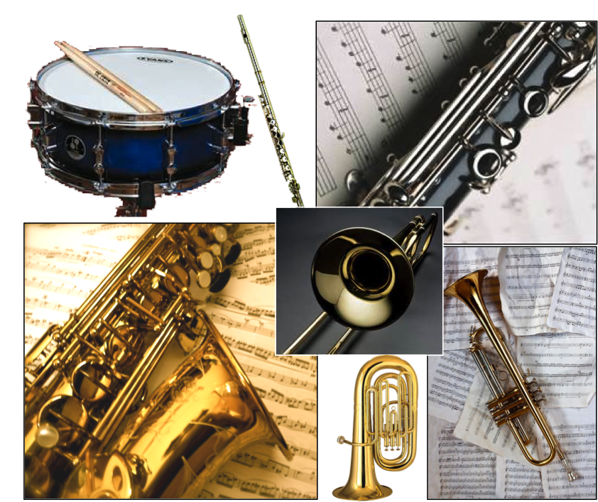
www.algomacommunityband.com
2022 - 2023

